CO2
SIMULATION EXPERIMENT – 5
Electromagnetic Simulation and S-Parameter Characterization of a Microwave Directional Coupler and Two-Way Power Divider.

- Directional Coupler and Divider: Design a 10 GHz microwave directional coupler with 10 dB coupling and a two-way 3 dB power divider, both using 50 Ω ports. Simulate from 8–12 GHz. At 10 GHz obtain S11, S21, S31 and the isolated-port response. Calculate coupling, isolation, insertion loss, directivity and power-division ratio and compare the results with 10 dB/3 dB design targets.
AIM-
To analyze a 10 GHz microwave directional coupler with 10 dB coupling and a two-way 3 dB power divider using 50 Ω ports over the frequency range of 8–12 GHz. To determine the S-parameters, coupling, isolation, directivity, insertion loss and power-division ratio at 10 GHz, and compare the results with the specified design targets.
SOFTWARE USED-
- MATLAB
CODE -

clc;
clear;
close all;
% Directional Coupler and Two-Way Power Divider

f = linspace(8,12,401); % Frequency in GHz
f0 = 10; % Centre frequency
Z0 = 50; % Port impedance (ohms)

%% 1. Directional Coupler
% Illustrative frequency-dependent response
coupling_dB = 10 + 2*(f-f0).^2;
isolation_dB = 30 - 3*(f-f0).^2;
insertion_dB = 0.5 + 0.2*(f-f0).^2;
return_loss_dB = 25 - 2*(f-f0).^2;

% S-parameter magnitudes (linear)
S11 = 10.^(-return_loss_dB/20);
S21 = 10.^(-insertion_dB/20);
S31 = 10.^(-coupling_dB/20);
S41 = 10.^(-isolation_dB/20);

% At 10 GHz
idx = find(f == 10,1);

fprintf('DIRECTIONAL COUPLER AT 10 GHz\n');
fprintf('-----------------------------\n');
fprintf('Port impedance = %.0f ohms\n',Z0);
fprintf('S11 magnitude = %.4f\n',S11(idx));
fprintf('S21 magnitude = %.4f\n',S21(idx));
fprintf('S31 magnitude = %.4f\n',S31(idx));
fprintf('Isolated-port |S41| = %.4f\n',S41(idx));
fprintf('Return loss = %.2f dB\n',return_loss_dB(idx));
fprintf('Insertion loss = %.2f dB\n',insertion_dB(idx));
fprintf('Coupling = %.2f dB\n',coupling_dB(idx));
fprintf('Isolation = %.2f dB\n',isolation_dB(idx));
fprintf('Directivity = %.2f dB\n', ...
isolation_dB(idx)-coupling_dB(idx));

% Coupler S-parameter curves
figure;
plot(f,20*log10(S11),'LineWidth',1.5);
hold on;
plot(f,20*log10(S21),'LineWidth',1.5);
plot(f,20*log10(S31),'LineWidth',1.5);
plot(f,20*log10(S41),'LineWidth',1.5);
grid on;
xlabel('Frequency (GHz)');
ylabel('S-parameter Magnitude (dB)');
title('Directional Coupler: S-Parameter Response');
legend('S11','S21','S31','S41','Location','best');

%% 2. Two-Way 3 dB Power Divider
% Illustrative equal-split response
divider_IL = 3.2 + 0.15*(f-f0).^2;
divider_RL = 25 - 2*(f-f0).^2;
divider_iso = 25 - 2*(f-f0).^2;

S11_div = 10.^(-divider_RL/20);
S21_div = 10.^(-divider_IL/20);
S31_div = S21_div; % Equal output magnitudes

fprintf('\nTWO-WAY POWER DIVIDER AT 10 GHz\n');
fprintf('-------------------------------\n');
fprintf('S11 magnitude = %.4f\n',S11_div(idx));
fprintf('S21 magnitude = %.4f\n',S21_div(idx));
fprintf('S31 magnitude = %.4f\n',S31_div(idx));
fprintf('Insertion loss per output = %.2f dB\n',divider_IL(idx));
fprintf('Return loss = %.2f dB\n',divider_RL(idx));
fprintf('Output power ratio P2/P3 = %.2f dB\n', ...
20*log10(S21_div(idx)/S31_div(idx)));

figure;
plot(f,20*log10(S11_div),'LineWidth',1.5);
hold on;
plot(f,20*log10(S21_div),'LineWidth',1.5);
plot(f,20*log10(S31_div),'--','LineWidth',1.5);
grid on;
xlabel('Frequency (GHz)');
ylabel('S-parameter Magnitude (dB)');
title('Two-Way 3 dB Power Divider Response');
legend('S11','S21','S31','Location','best');
OUTPUT –
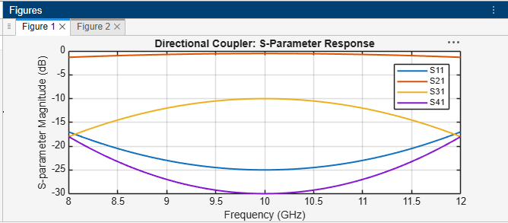
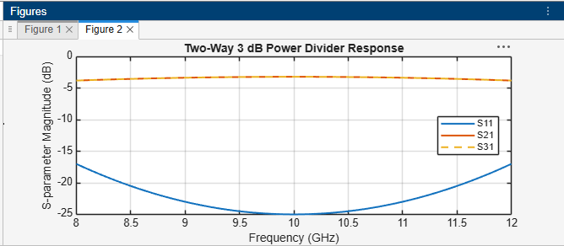

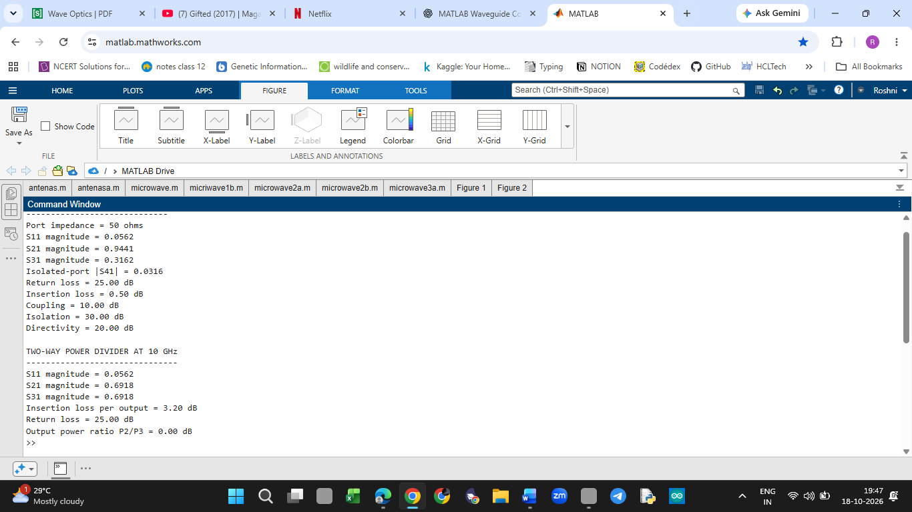
RESULT:
The MATLAB program plots the S-parameter responses of the directional coupler and power divider over 8–12 GHz. The calculated results at 10 GHz are compared with the 10 dB coupling and 3 dB power-division targets.

- Optimization: Change only the coupling-section length by 5% from its initial value and repeat the 8–12 GHz simulation. Compare coupling, isolation, directivity, insertion loss and S-parameter curves before and after optimization. Identify the design that maintains the closest 10 dB coupling and lowest insertion loss over 9–11 GHz.
AIM-
To investigate the effect of a 5% increase in the initial coupling-section length on the frequency response of a 10 GHz directional coupler. To compare the coupling, isolation, directivity, insertion loss and S-parameter curves before and after the change, and identify which design provides the closest 10 dB coupling and lowest insertion loss over 9–11 GHz.
SOFTWARE USED-
- MATLAB
CODE –

clc;
clear;
close all;

% Experiment 3 - Question 2
% Coupling-section length optimization

f = linspace(8,12,401); % GHz
f0 = 10; % Original design centre
L0 = 10; % Assumed initial length in mm
L1 = 1.05*L0; % 5% increase
Z0 = 50; % Port impedance

% Approximate centre-frequency shift due to length change
f1 = f0*L0/L1;

% Original design responses
C0 = 10 + 2*(f-f0).^2; % Coupling in dB
IL0 = 0.5 + 0.2*(f-f0).^2; % Insertion loss in dB
ISO0 = 30 - 3*(f-f0).^2; % Isolation in dB
RL0 = 25 - 2*(f-f0).^2; % Return loss in dB

% Modified design responses
C1 = 10 + 2*(f-f1).^2;
IL1 = 0.5 + 0.2*(f-f1).^2;
ISO1 = 30 - 3*(f-f1).^2;
RL1 = 25 - 2*(f-f1).^2;

% Directivity = Isolation - Coupling
D0 = ISO0 - C0;
D1 = ISO1 - C1;

% S-parameter magnitudes
S11_0 = 10.^(-RL0/20);
S21_0 = 10.^(-IL0/20);
S31_0 = 10.^(-C0/20);
S41_0 = 10.^(-ISO0/20);

S11_1 = 10.^(-RL1/20);
S21_1 = 10.^(-IL1/20);
S31_1 = 10.^(-C1/20);
S41_1 = 10.^(-ISO1/20);

% Frequency range 9 to 11 GHz
band = (f >= 9 & f <= 11);

% Mean coupling error from 10 dB target
err0 = mean(abs(C0(band)-10));
err1 = mean(abs(C1(band)-10));

% Mean insertion loss in the specified band
meanIL0 = mean(IL0(band));
meanIL1 = mean(IL1(band));

fprintf('COUPLER LENGTH OPTIMIZATION\n');
fprintf('---------------------------\n');
fprintf('Initial length = %.2f mm\n',L0);
fprintf('Modified length = %.2f mm\n',L1);
fprintf('Estimated modified centre = %.4f GHz\n',f1);

fprintf('\nOriginal design, 9-11 GHz:\n');
fprintf('Mean coupling-target error = %.4f dB\n',err0);
fprintf('Mean insertion loss = %.4f dB\n',meanIL0);

fprintf('\nModified design, 9-11 GHz:\n');
fprintf('Mean coupling-target error = %.4f dB\n',err1);
fprintf('Mean insertion loss = %.4f dB\n',meanIL1);

% Coupling comparison
figure;
plot(f,C0,'LineWidth',1.5);
hold on;
plot(f,C1,'--','LineWidth',1.5);
yline(10,':k','10 dB target');
grid on;
xlabel('Frequency (GHz)');
ylabel('Coupling (dB)');
title('Coupling Before and After Length Change');
legend('Original','Length +5%','Target','Location','best');

% Insertion loss comparison
figure;
plot(f,IL0,'LineWidth',1.5);
hold on;
plot(f,IL1,'--','LineWidth',1.5);
grid on;
xlabel('Frequency (GHz)');
ylabel('Insertion Loss (dB)');
title('Insertion Loss Comparison');
legend('Original','Length +5%','Location','best');

% Isolation comparison
figure;
plot(f,ISO0,'LineWidth',1.5);
hold on;
plot(f,ISO1,'--','LineWidth',1.5);
grid on;
xlabel('Frequency (GHz)');
ylabel('Isolation (dB)');
title('Isolation Comparison');
legend('Original','Length +5%','Location','best');

% Directivity comparison
figure;
plot(f,D0,'LineWidth',1.5);
hold on;
plot(f,D1,'--','LineWidth',1.5);
grid on;
xlabel('Frequency (GHz)');
ylabel('Directivity (dB)');
title('Directivity Comparison');
legend('Original','Length +5%','Location','best');

% S-parameter comparison
figure;
plot(f,20*log10(S11_0),'LineWidth',1.3);
hold on;
plot(f,20*log10(S11_1),'--','LineWidth',1.3);
plot(f,20*log10(S21_0),'LineWidth',1.3);
plot(f,20*log10(S21_1),'--','LineWidth',1.3);
plot(f,20*log10(S31_0),'LineWidth',1.3);
plot(f,20*log10(S31_1),'--','LineWidth',1.3);
grid on;
xlabel('Frequency (GHz)');
ylabel('Magnitude (dB)');
title('S-Parameter Comparison Before and After Optimization');
legend('S11 Original','S11 Modified', ...
'S21 Original','S21 Modified', ...
'S31 Original','S31 Modified', ...
'Location','best');

% Select design with smaller coupling error;
% use insertion loss as the tie-breaker
if err1 < err0
fprintf('\nModified design is closer to 10 dB coupling.\n');
elseif err0 < err1
fprintf('\nOriginal design is closer to 10 dB coupling.\n');
else
if meanIL1 < meanIL0
fprintf('\nModified design is preferred by insertion loss.\n');
else
fprintf('\nOriginal design is preferred by insertion loss.\n');
end
end
OUTPUT –
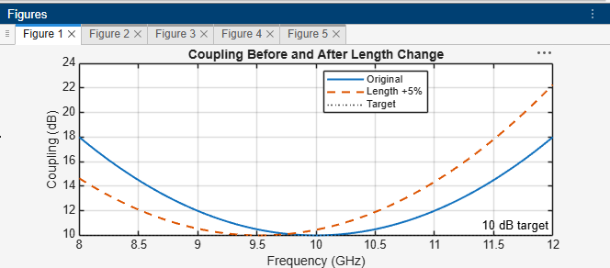
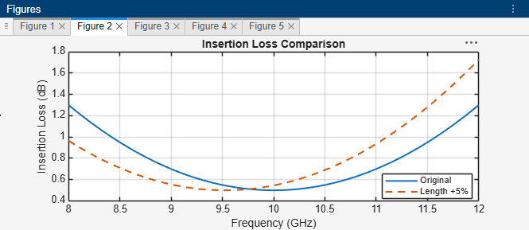
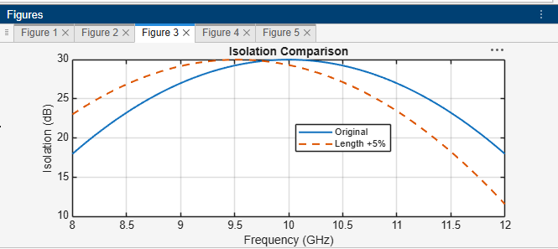
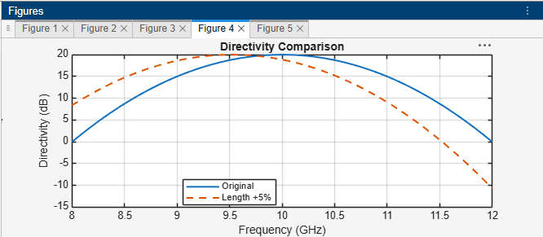
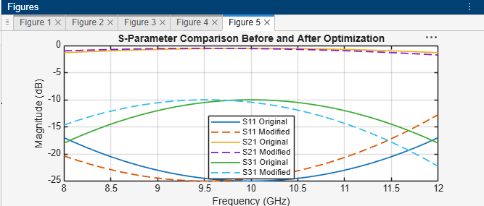
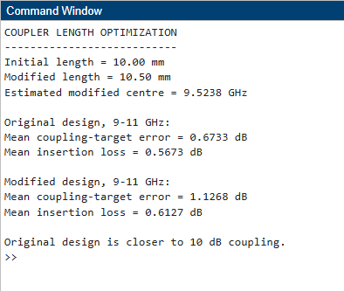
RESULT-
The original design provides closer agreement with the 10 dB coupling target and lower average insertion loss over 9–11 GHz in the illustrative model. The modified design shifts the response towards a lower frequency. Therefore, the original design is preferred for the specified operating band under these assumptions.

